MySQL Basic SELECT statement [19 Exercises]

Q1) **1.** Write a query to display the names (first_name, last_name) using alias name "First Name", "Last Name"

[SELECT](http://localhost/phpmyadmin/url.php?url=https://dev.mysql.com/doc/refman/8.0/en/select.html) FIRST_NAME AS "First Name" , LAST_NAME AS "Last Name" FROM employees;

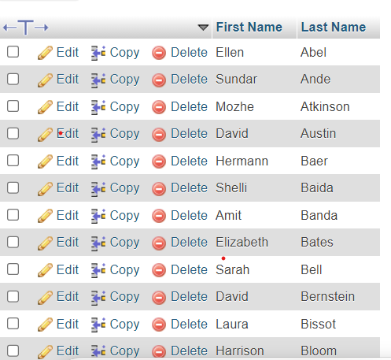

Q2) Write a query to get unique department ID from employee table.

SELECT DISTINCT DEPARTMENT_ID FROM employees;

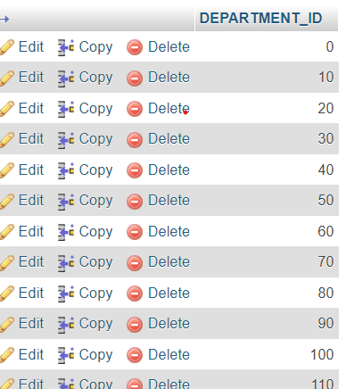

Q3)  Write a query to get all employee details from the employee table order by first name, descending.

[SELECT](http://localhost/phpmyadmin/url.php?url=https://dev.mysql.com/doc/refman/8.0/en/select.html) * FROM `employees` ORDER BY FIRST_NAME DESC;

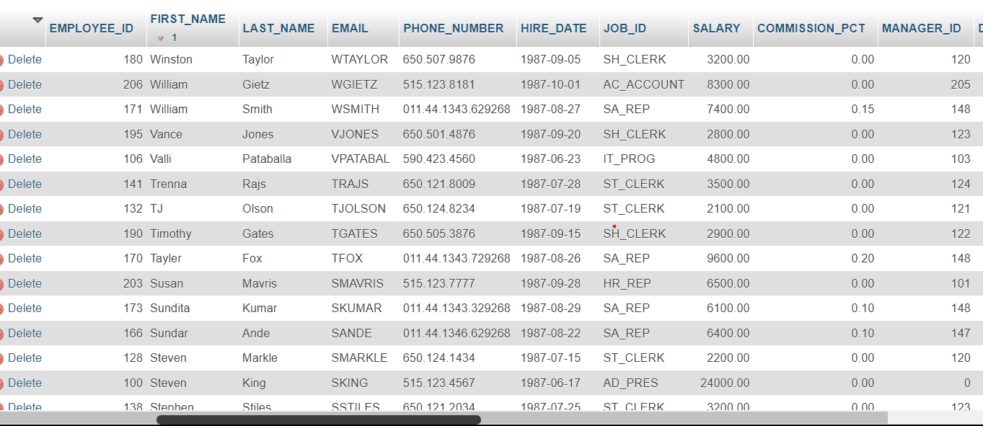

Q4) Write a query to get the names (first_name, last_name), salary, PF of all the employees (PF is calculated as 15% of salary).

SELECT FIRST_NAME, LAST_NAME, SALARY, (SALARY * 0.15) AS PF FROM employees;

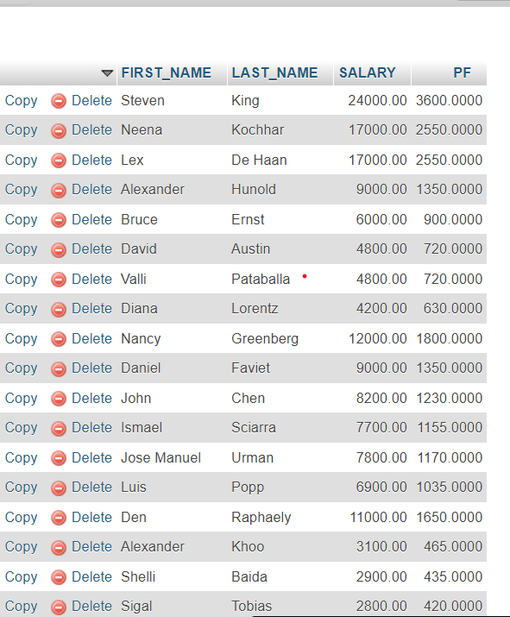

Q **5.** Write a query to get the employee ID, names (first_name, last_name), salary in ascending order of salary.

SELECT EMPLOYEE_ID,FIRST_NAME,LAST_NAME,SALARY FROM `employees` ORDER BY SALARY ASC

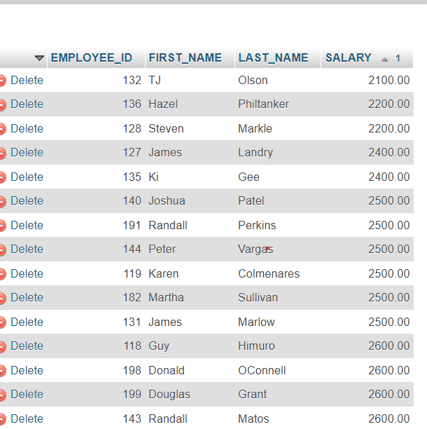

Q **6.** Write a query to get the total salaries payable to employees

SELECT SUM(SALARY) AS "TOTAL SALARY" FROM `employees`

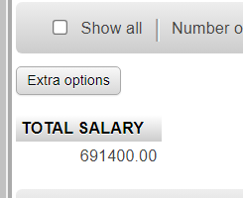

Q7) rite a query to get the maximum and minimum salary from employees table.

SELECT MAX(SALARY) ,MIN(SALARY) AS "MAX SALARY ","MIN SALARY" FROM `employees`

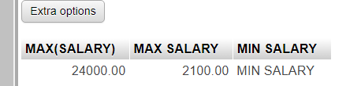

Q 8)Write a query to get the average salary and number of employees in the employees table.

SELECT AVG(SALARY) AS "AVERAGE SALARY",COUNT(EMPLOYEE_ID)AS "EMPLOYEE COUNT" FROM `employees`



Q **9).** Write a query to get the number of employees working with the company.

SELECT COUNT (EMPLOYEE_ID) AS "NO OF WORKING EPMLOYEE" FROM `employees`

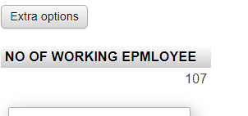

Q10) Write a query to get the number of jobs available in the employees table

[SELECT](http://localhost/phpmyadmin/url.php?url=https://dev.mysql.com/doc/refman/8.0/en/select.html) [COUNT](http://localhost/phpmyadmin/url.php?url=https://dev.mysql.com/doc/refman/8.0/en/aggregate-functions.html%23function_count)(DISTINCT JOB_ID) FROM `employees`;



Q**11.** Write a query get all first name from employees table in upper case.

SELECT UPPER(FIRST_NAME) FROM employees

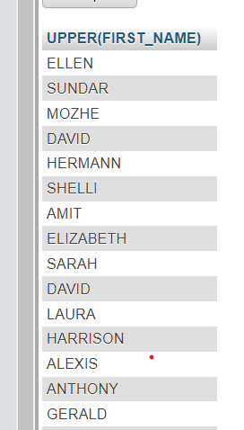

Q12) Write a query to get the first 3 characters of first name from employees table.

[SELECT](http://localhost/phpmyadmin/url.php?url=https://dev.mysql.com/doc/refman/8.0/en/select.html) SUBSTRING(first_name, 1, 3) FROM employees;

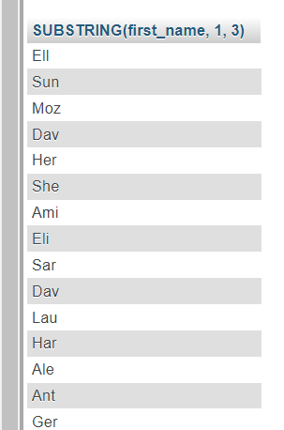

Q **13.)** Write a query to calculate 171*214+625.

[SELECT](http://localhost/phpmyadmin/url.php?url=https://dev.mysql.com/doc/refman/8.0/en/select.html) 171*214+625;

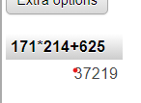

Q **14.** Write a query to get the names (for example Ellen Abel, Sundar Ande etc.) of all the employees from employees table.

SELECT CONCAT(FIRST_NAME," ",LAST_NAME )AS "NAMES"FROM `employees`;

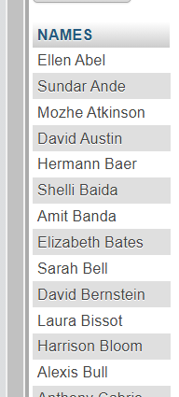

**Q15.** Write a query to get first name from employees table after removing white spaces from both side.

SELECT TRIM(FIRST_NAME) FROM `employees`

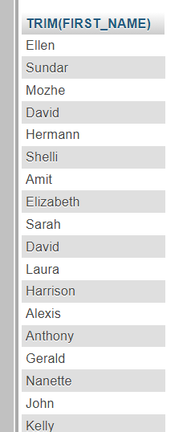

Q **16.** Write a query to get the length of the employee names (first_name, last_name) from employees table.

SELECT FIRST_NAME,LAST_NAME,LENGTH(FIRST_NAME)+LENGTH(LAST_NAME) AS "LENGTH OF NAMES" FROM `employees`

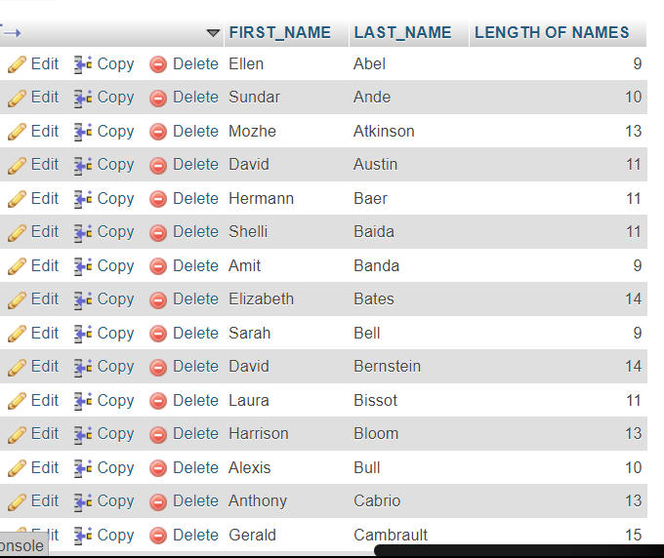

Q **17.** Write a query to check if the first_name fields of the employees table contains numbers.

SELECT * FROM `employees` WHERE first_name REGEXP '[0-9]';

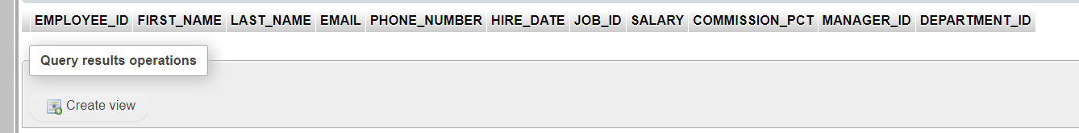

Q **18.** Write a query to select first 10 records from a table.

SELECT EMPLOYEE_ID,FIRST_NAME FROM employees LIMIT 10;

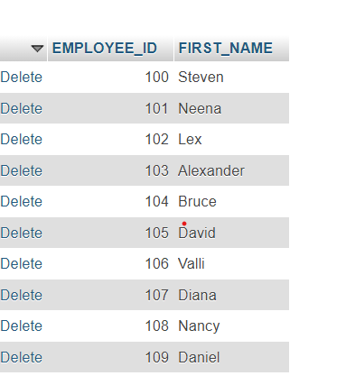

Q **19.** Write a query to get monthly salary (round 2 decimal places) of each and every employee

SELECT FIRST_NAME,LAST_NAME, ROUND(SALARY / 12, 2) AS 'Monthly Salary' FROM employees

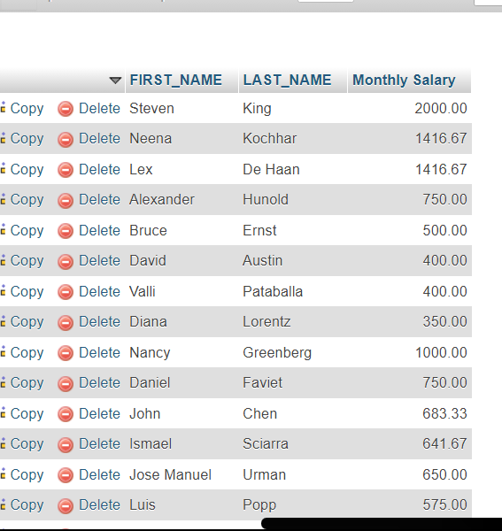

MySQL Restricting and Sorting Data [11 Exercises]

Q **1.** Write a query to display the name (first_name, last_name) and salary for all employees whose salary is not in the range $10,000 through $15,000.

SELECT FIRST_NAME,LAST_NAME FROM employees WHERE salary NOT BETWEEN 10000 AND 15000;

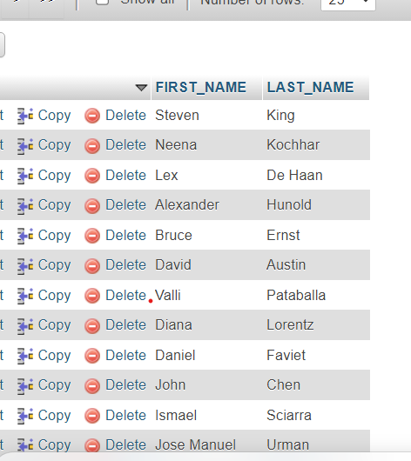

**2.** Write a query to display the name (first_name, last_name) and department ID of all employees in departments 30 or 100 in ascending order.

SELECT FIRST_NAME , LAST_NAME ,DEPARTMENT_ID FROM employees WHERE department_id IN (30, 100) ORDER BY DEPARTMENT_ID ASC;

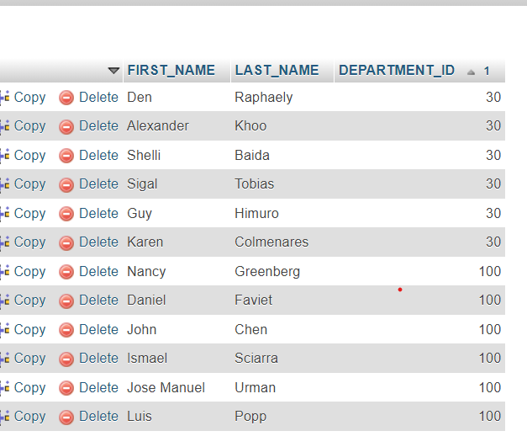

**3.** Write a query to display the name (first_name, last_name) and salary for all employees whose salary is not in the range $10,000 through $15,000 and are in department 30 or 100.

SELECT FIRST_NAME , LAST_NAME,DEPARTMENT_ID ,SALARY FROM employees WHERE SALARY NOT BETWEEN 10000 AND 15000 AND DEPARTMENT_ID IN (30,100)

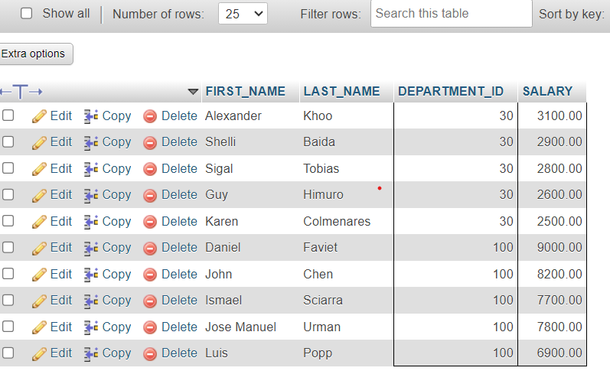

**5.** Write a query to display the first_name of all employees who have both "b" and "c" in their first name.

SELECT FIRST_NAME FROM employees WHERE FIRST_NAME LIKE '%b%' AND FIRST_NAME LIKE '%c%';



**6.** Write a query to display the last name, job, and salary for all employees whose job is that of a Programmer or a Shipping Clerk, and whose salary is not equal to $4,500, $10,000, or $15,000.

SELECT LAST_NAME ,JOB_ID,SALARY FROM `employees` WHERE JOB_ID IN ('IT_PROG', 'SH_CLERK')

AND SALARY NOT IN (4500, 10000, 15000);

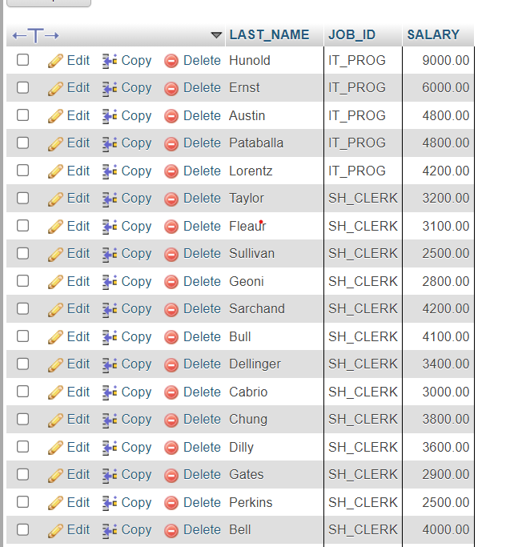

**7.** Write a query to display the last name of employees whose names have exactly 6 characters.

SELECT LAST_NAME FROM `employees` WHERE LAST_NAME LIKE "______"

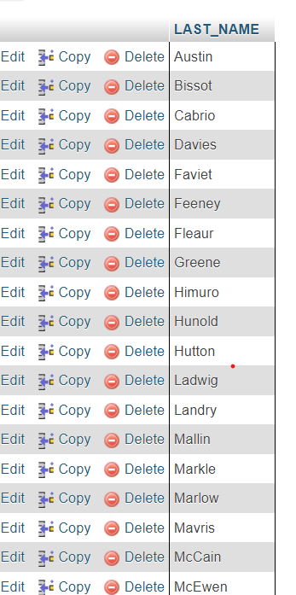

**8.** Write a query to display the last name of employees having 'e' as the third character.

SELECT LAST_NAME FROM employees WHERE LAST_NAME LIKE "%%e"

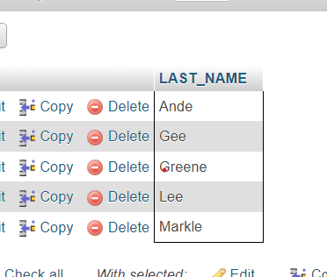

**9.** Write a query to display the jobs/designations available in the employees table.

SELECT DISTINCT JOB_ID FROM `employees`

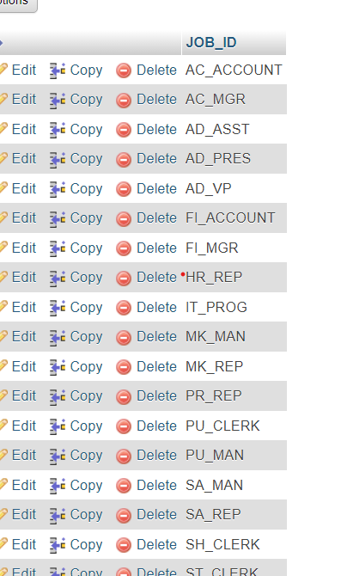

**10.** Write a query to display the name (first_name, last_name), salary and PF (15% of salary) of all employees.

SELECT FIRST_NAME,LAST_NAME,SALARY,SALARY*0.15 AS PF FROM `employees`

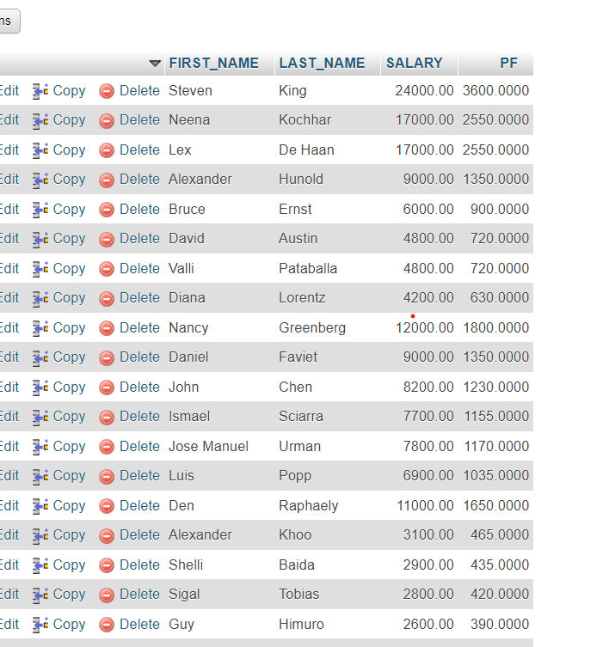

**11.** Write a query to select all record from employees where last name in 'BLAKE', 'SCOTT', 'KING' and 'FORD'.

SELECT * FROM `employees`WHERE LAST_NAME IN ('JONES', 'BLAKE', 'SCOTT', 'KING', 'FORD');

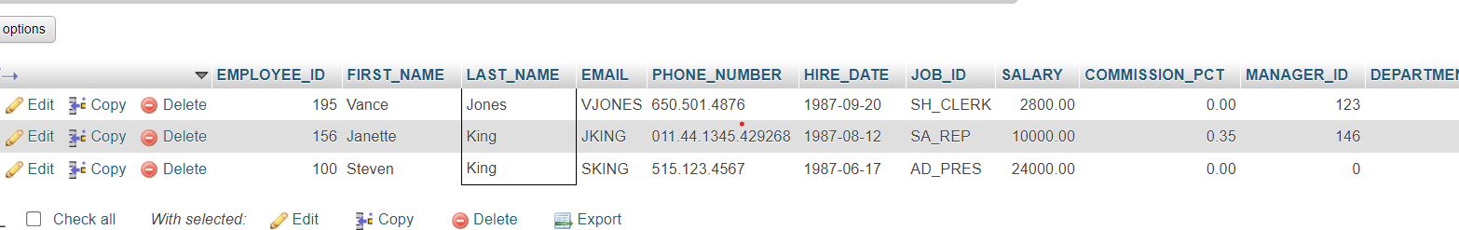

Aggregate Functions and Group by [14 exercises with solution]

1. Write a query to list the number of jobs available in the employees table.

SELECT COUNT( DISTINCT JOB_ID) AS "No of jobs" FROM `employees`

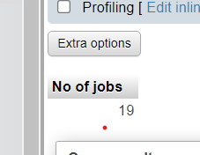

1. Write a query to get the total salaries payable to employees.

SELECT SUM(SALARY) AS "TOTAL SALARY"FROM `employees`

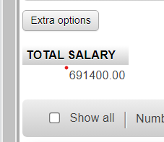

1. Write a query to get the minimum salary from employees table.

SELECT MIN(SALARY) AS "MAX SALARY" FROM `employees`



**4.** Write a query to get the maximum salary of an employee working as a Programmer.

SELECT MAX(SALARY) AS "MAX SALARY OF PROGRAMER " FROM `employees` WHERE JOB_ID="IT_PROG"

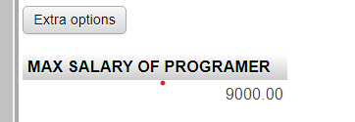

**5.** Write a query to get the average salary and number of employees working the department 90.

SELECT AVG(SALARY) AS "Avrage of salary" ,COUNT(EMPLOYEE_ID) AS "Total employes" FROM `employees` WHERE DEPARTMENT_ID=90

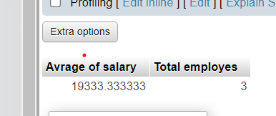

**6.** Write a query to get the highest, lowest, sum, and average salary of all employees

SELECT MAX(SALARY)AS "Highest Salary", MIN(SALARY)AS "Lowest Salary",SUM(SALARY) AS "Sum of Salary",AVG(SALARY) AS "Average of Salary" FROM employees

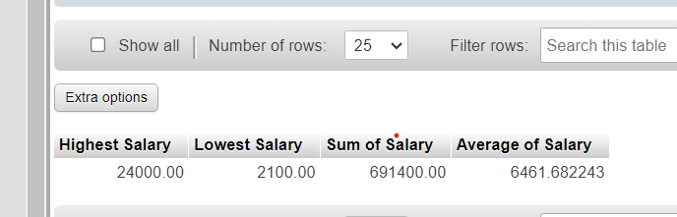

**7.**Write a query to get the number of employees with the same job

SELECT JOB_ID AS "jobs" , COUNT(EMPLOYEE_ID) AS "Employess" FROM `employees` GROUP BY JOB_ID

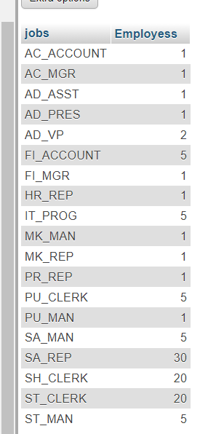

**8.** Write a query to get the difference between the highest and lowest salaries.

SELECT MAX(SALARY)-MIN(SALARY) AS "Diffrence Between Highest And Lowest Salary "FROM `employees`

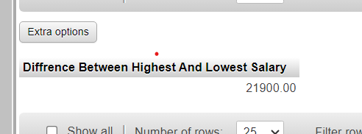

**9.** Write a query to find the manager ID and the salary of the lowest-paid employee for that manager.

[SELECT](http://localhost/phpmyadmin/url.php?url=https://dev.mysql.com/doc/refman/8.0/en/select.html) MANAGER_ID,[MIN](http://localhost/phpmyadmin/url.php?url=https://dev.mysql.com/doc/refman/8.0/en/aggregate-functions.html%23function_min)(SALARY) AS low FROM employees GROUP BY MANAGER_ID;

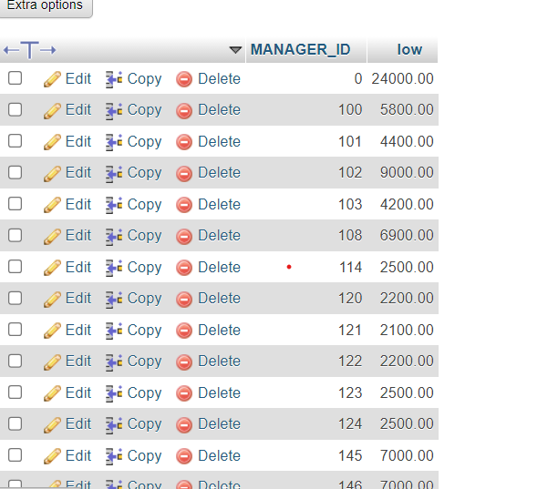

**10.** Write a query to get the department ID and the total salary payable in each department.

SELECT DISTINCT DEPARTMENT_ID,SUM(SALARY) AS "TOTAL SALARY" FROM `employees` GROUP BY DEPARTMENT_ID

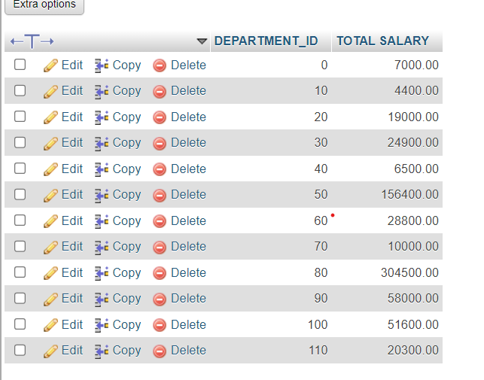

**11.** Write a query to get the average salary for each job ID excluding programmer.

[SELECT](http://localhost/phpmyadmin/url.php?url=https://dev.mysql.com/doc/refman/8.0/en/select.html) JOB_ID AS JOB ,[AVG](http://localhost/phpmyadmin/url.php?url=https://dev.mysql.com/doc/refman/8.0/en/aggregate-functions.html%23function_avg)(SALARY) AS "AVERAGE OF SALARY" FROM employees WHERE JOB_ID !="IT_PROG" GROUP BY JOB_ID;

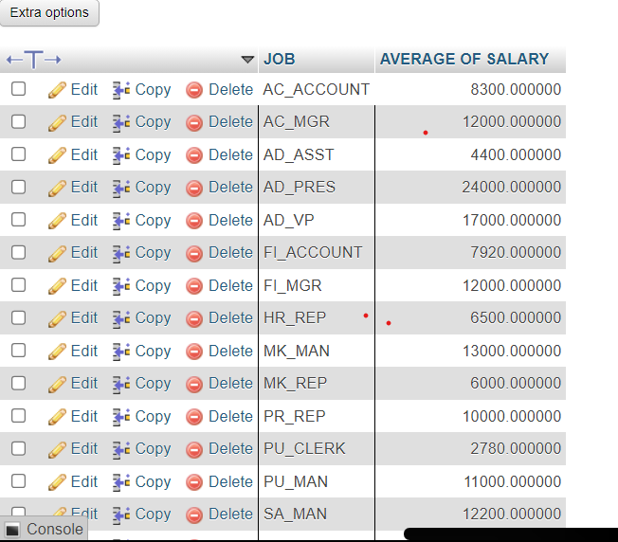

**12.** Write a query to get the total salary, maximum, minimum, average salary of employees (job ID wise), for department ID 90 only.

SELECT JOB_ID, SUM(SALARY)AS "Total salary",AVG(SALARY)AS "AVG salary",MIN(SALARY)AS "Min salary",MAX(SALARY)AS "Max salary" FROM `employees` WHERE DEPARTMENT_ID=90 GROUP BY JOB_ID;

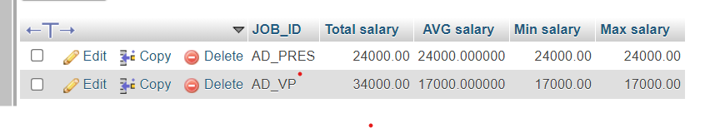

**13.** Write a query to get the job ID and maximum salary of the employees where maximum salary is greater than or equal to $4000.

SELECT JOB_ID,MAX(SALARY) FROM `employees` WHERE SALARY>=4000 GROUP BY JOB_ID  
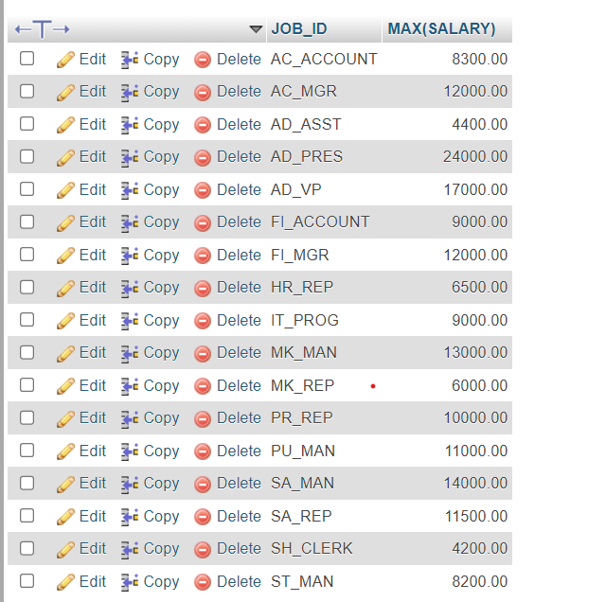

**14.** Write a query to get the average salary for all departments employing more than 10 employees.

SELECT DEPARTMENT_ID,AVG(SALARY) FROM `employees` GROUP BY DEPARTMENT_ID HAVING COUNT(EMPLOYEE_ID)>10

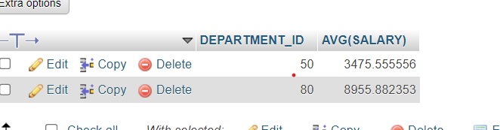

MySQL Subqueries [22 Exercises]

1. Write a [MySQL](https://www.w3resource.com/mysql-exercises/subquery-exercises/) query to find the name (first_name, last_name) and the salary of the employees who have a higher salary than the employee whose last_name='Bull'.

SELECT FIRST_NAME,LAST_NAME,SALARY FROM `employees` WHERE SALARY>(SELECT SALARY FROM employees WHERE LAST_NAME="Bull")

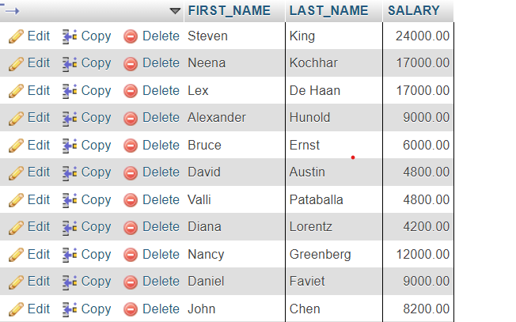

1. Write a [MySQL](https://www.w3resource.com/mysql-exercises/subquery-exercises/) query to find the name (first_name, last_name) of all employees who works in the IT department.

SELECT FIRST_NAME AS "NAME",LAST_NAME AS "SURNAME" FROM `employees` WHERE DEPARTMENT_ID= (SELECT DEPARTMENT_NAME FROM departments WHERE DEPARTMENT_NAME="IT")



1. Write a [MySQL](https://www.w3resource.com/mysql-exercises/subquery-exercises/) query to find the name (first_name, last_name) of the employees who have a manager and worked in a USA based department.

SELECT first_name AS "NAME", last_name AS "SURNAME" FROM employees WHERE manager_id in (SELECT employee_id FROM employees WHERE department_id IN(SELECT department_id FROM departments WHERE location_id IN (SELECT location_id FROM locations WHERE country_id='US')) );

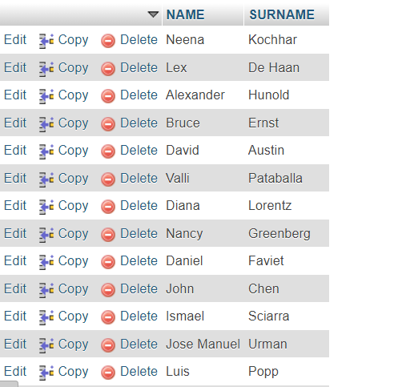

1. Write a [MySQL](https://www.w3resource.com/mysql-exercises/subquery-exercises/) query to find the name (first_name, last_name) of the employees who are managers.

SELECT FIRST_NAME,LAST_NAME FROM `employees` WHERE EMPLOYEE_ID IN(SELECT MANAGER_ID FROM employees)

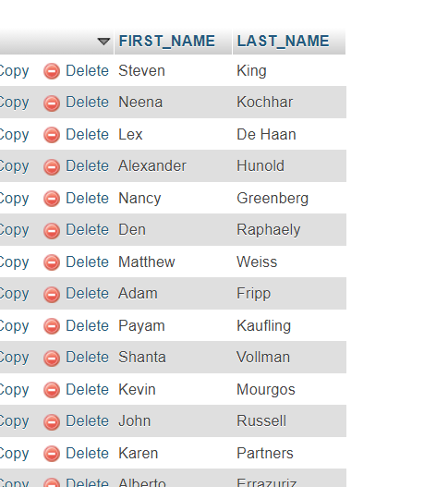

1. Write a [MySQL](https://www.w3resource.com/mysql-exercises/subquery-exercises/) query to find the name (first_name, last_name), and salary of the employees whose salary is greater than the average salary.

SELECT FIRST_NAME,LAST_NAME FROM `employees` WHERE SALARY>(SELECT AVG(SALARY) FROM employees)

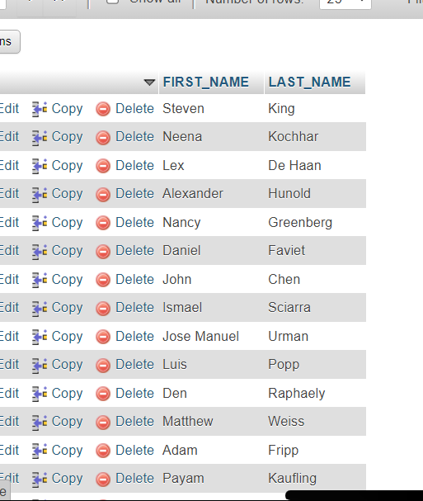

1. Write a [MySQL](https://www.w3resource.com/mysql-exercises/subquery-exercises/) query to find the name (first_name, last_name), and salary of the employees whose salary is equal to the minimum salary for their job grade.

[SELECT](http://localhost/phpmyadmin/url.php?url=https://dev.mysql.com/doc/refman/8.0/en/select.html) FIRST_NAME,LAST_NAME,SALARY FROM `employees` WHERE employees.SALARY =(

[SELECT](http://localhost/phpmyadmin/url.php?url=https://dev.mysql.com/doc/refman/8.0/en/select.html) [MIN](http://localhost/phpmyadmin/url.php?url=https://dev.mysql.com/doc/refman/8.0/en/aggregate-functions.html%23function_min)(SALARY) FROM jobs WHERE employees.JOB_ID=jobs.JOB_ID);

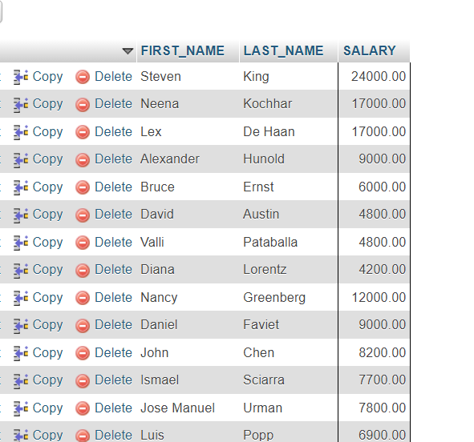

1. Write a [MySQL](https://www.w3resource.com/mysql-exercises/subquery-exercises/) query to find the name (first_name, last_name), and salary of the employees who earns more than the average salary and works in any of the IT departments.

[SELECT](http://localhost/phpmyadmin/url.php?url=https://dev.mysql.com/doc/refman/8.0/en/select.html) FIRST_NAME,LAST_NAME,SALARY FROM `employees` WHERE DEPARTMENT_ID [IN](http://localhost/phpmyadmin/url.php?url=https://dev.mysql.com/doc/refman/8.0/en/comparison-operators.html%23function_in) ([SELECT](http://localhost/phpmyadmin/url.php?url=https://dev.mysql.com/doc/refman/8.0/en/select.html) DEPARTMENT_ID FROM departments WHERE DEPARTMENT_NAME [LIKE](http://localhost/phpmyadmin/url.php?url=https://dev.mysql.com/doc/refman/8.0/en/string-comparison-functions.html%23operator_like) "%IT%") [AND](http://localhost/phpmyadmin/url.php?url=https://dev.mysql.com/doc/refman/8.0/en/logical-operators.html%23operator_and) SALARY>([SELECT](http://localhost/phpmyadmin/url.php?url=https://dev.mysql.com/doc/refman/8.0/en/select.html) [AVG](http://localhost/phpmyadmin/url.php?url=https://dev.mysql.com/doc/refman/8.0/en/aggregate-functions.html%23function_avg)(SALARY)FROM employees );

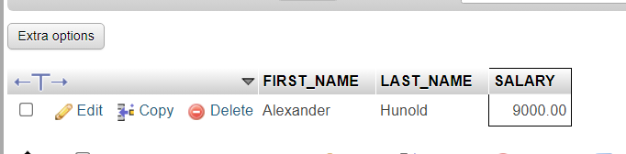

1. Write a [MySQL](https://www.w3resource.com/mysql-exercises/subquery-exercises/) query to find the name (first_name, last_name), and salary of the employees who earns more than the earning of Mr. Bell

SELECT first_name, last_name, salary FROM employees

WHERE salary >(SELECT MAX(salary) FROM employees WHERE last_name = 'Bell')

ORDER BY first_name;

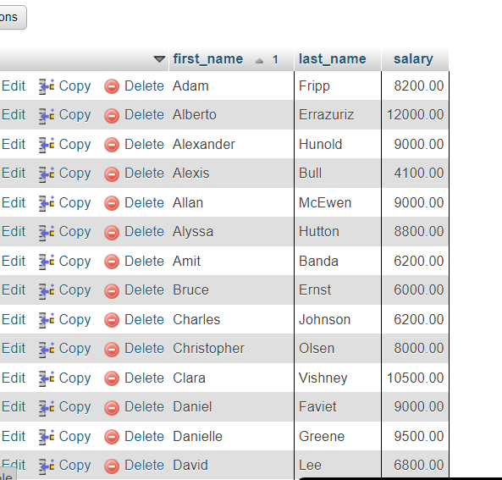

**9.** Write a [MySQL](https://www.w3resource.com/mysql-exercises/subquery-exercises/) query to find the name (first_name, last_name), and salary of the employees who earn the same salary as the minimum salary for all departments.

SELECT FIRST_NAME, LAST_NAME, SALARY

FROM employees

WHERE SALARY = (SELECT MIN(SALARY) FROM employees);

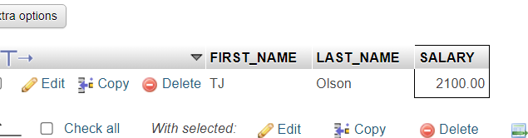

1. Write a [MySQL](https://www.w3resource.com/mysql-exercises/subquery-exercises/) query to find the name (first_name, last_name), and salary of the employees whose salary is greater than the average salary of each department.

[SELECT](http://localhost/phpmyadmin/url.php?url=https://dev.mysql.com/doc/refman/8.0/en/select.html) FIRST_NAME, LAST_NAME, SALARY FROM employees e WHERE SALARY > ( [SELECT](http://localhost/phpmyadmin/url.php?url=https://dev.mysql.com/doc/refman/8.0/en/select.html) [AVG](http://localhost/phpmyadmin/url.php?url=https://dev.mysql.com/doc/refman/8.0/en/aggregate-functions.html%23function_avg)(SALARY) FROM employees WHERE DEPARTMENT_ID = e.DEPARTMENT_ID );

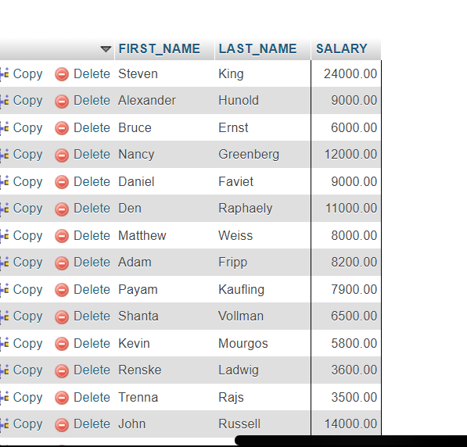

**11.** Write a [MySQL](https://www.w3resource.com/mysql-exercises/subquery-exercises/) query to find the name (first_name, last_name) and salary of the employees who earn a salary that is higher than the salary of all the Shipping Clerk (JOB_ID = 'SH_CLERK'). Sort the results of the salary of the lowest to highest.

SELECT FIRST_NAME,LAST_NAME,SALARY FROM employees WHERE SALARY>(SELECT MAX(SALARY) FROM employees WHERE JOB_ID = 'SH_CLERK')

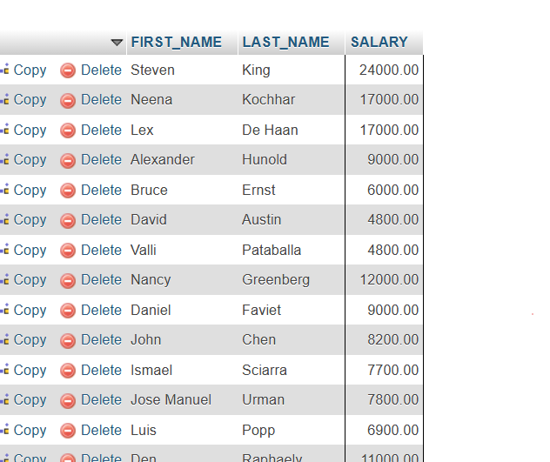

**12.** Write a [MySQL](https://www.w3resource.com/mysql-exercises/subquery-exercises/) query to find the name (first_name, last_name) of the employees who are not supervisors.

SELECT FIRST_NAME, LAST_NAME FROM `employees` WHERE EMPLOYEE_ID NOT IN (SELECT MANAGER_ID FROM employees );  
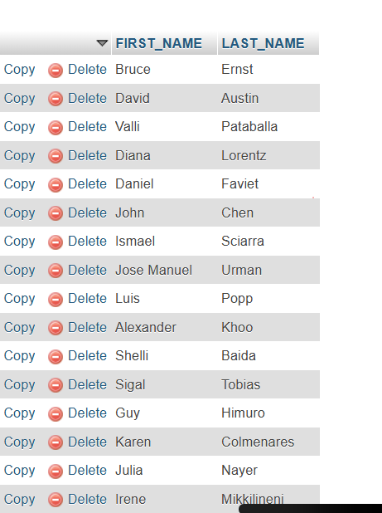

**13.** Write a [MySQL](https://www.w3resource.com/mysql-exercises/subquery-exercises/) query to display the employee ID, first name, last name, and department names of all employees.

[SELECT](http://localhost/phpmyadmin/url.php?url=https://dev.mysql.com/doc/refman/8.0/en/select.html) FIRST_NAME, LAST_NAME, DEPARTMENT_ID, ([SELECT](http://localhost/phpmyadmin/url.php?url=https://dev.mysql.com/doc/refman/8.0/en/select.html) DEPARTMENT_NAME FROM departments WHERE departments.DEPAR TMENT_ID = employees.DEPARTMENT_ID) AS department_name FROM employees;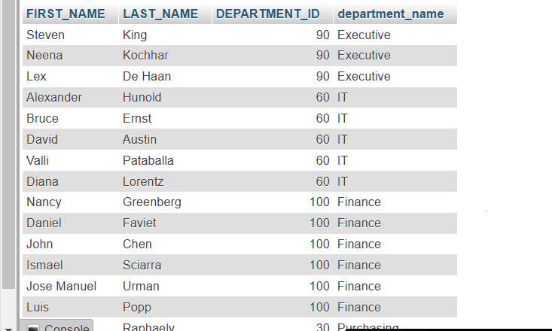

**14.** Write a [MySQL](https://www.w3resource.com/mysql-exercises/subquery-exercises/) query to display the employee ID, first name, last name, salary of all employees whose salary is above average for their departments.

SELECT FIRST_NAME, LAST_NAME,DEPARTMENT_ID, SALARY FROM employees AS E1 WHERE E1.SALARY > (SELECT AVG(SALARY) FROM employees AS E2 WHERE E1.DEPARTMENT_ID=E2.DEPARTMENT_ID)

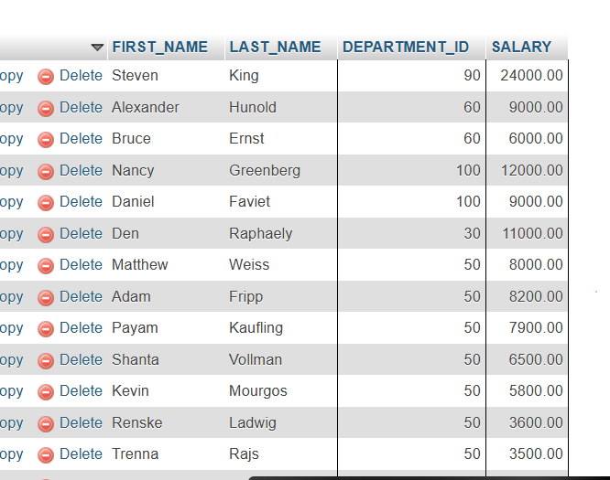

**15.** Write a [MySQL](https://www.w3resource.com/mysql-exercises/subquery-exercises/) query to fetch even numbered records from employees table.  
SELECT * FROM (SELECT ROW_NUMBER() OVER (ORDER BY EMPLOYEE_ID) AS SRNO,EMPLOYEE_ID,FIRST_NAME,LAST_NAME

FROM employees ORDER BY EMPLOYEE_ID) AS SRC WHERE SRNO % 2=0;  
 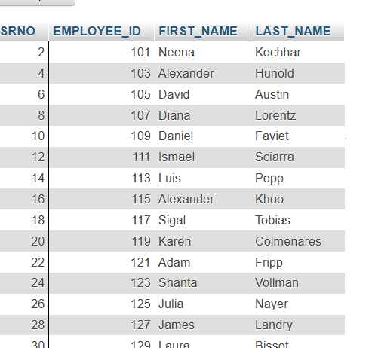  
  
**16.** Write a MySQL query to find the 4th minimum salary in the employees table.

SELECT DISTINCT SALARY FROM employees ORDER BY SALARY DESC LIMIT 1 OFFSET 4;  


**17.** Write a [MySQL](https://www.w3resource.com/mysql-exercises/subquery-exercises/) query to find the 5th Maximum salary in the employees table.

SELECT DISTINCT SALARY FROM employees ORDER BY SALARY ASC LIMIT 1 OFFSET 3;



**18.** Write a [MySQL](https://www.w3resource.com/mysql-exercises/subquery-exercises/) query to select last 10 records from a table.  
SELECT * FROM employees ORDER BY EMPLOYEE_ID DESC LIMIT 10

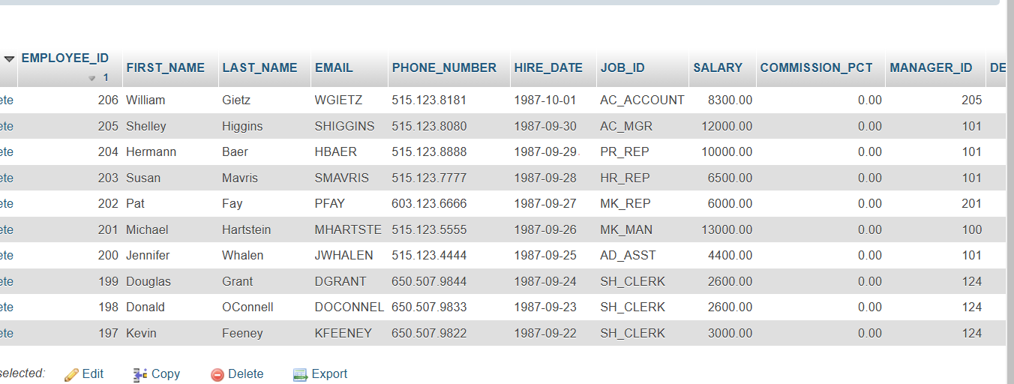

**19.** Write a [MySQL](https://www.w3resource.com/mysql-exercises/subquery-exercises/) query to list the department ID and name of all the departments where no employee is working.

SELECT * FROM departments WHERE DEPARTMENT_ID NOT IN ( SELECT DEPARTMENT_ID FROM employees)  
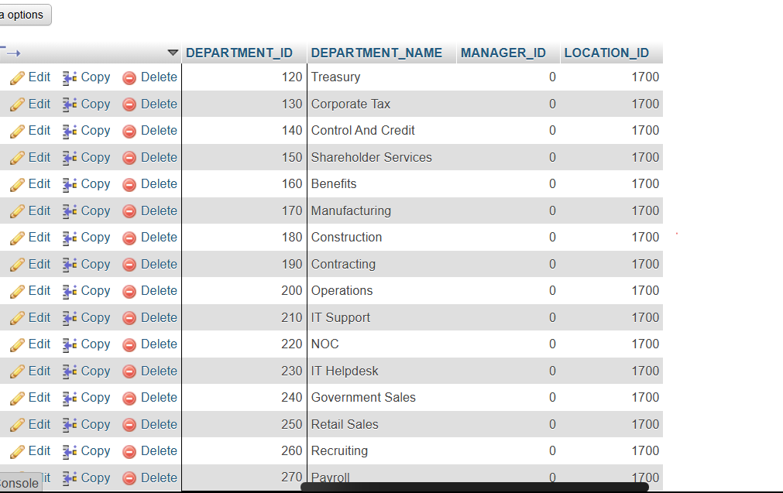

**20.** Write a [MySQL](https://www.w3resource.com/mysql-exercises/subquery-exercises/) query to get 3 maximum salaries.

SELECT SALARY FROM employees ORDER BY SALARY DESC LIMIT 3

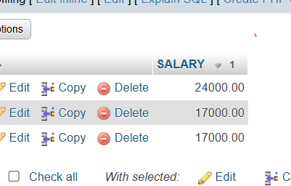

**21.** Write a [MySQL](https://www.w3resource.com/mysql-exercises/subquery-exercises/) query to get 3 minimum salaries.

[SELECT](http://localhost/phpmyadmin/url.php?url=https://dev.mysql.com/doc/refman/8.0/en/select.html) SALARY FROM employees ORDER BY SALARY ASC LIMIT 3;



**22.** Write a [MySQL](https://www.w3resource.com/mysql-exercises/subquery-exercises/) query to get nth max salaries of employees.

[SELECT](http://localhost/phpmyadmin/url.php?url=https://dev.mysql.com/doc/refman/8.0/en/select.html) SALARY FROM employees ORDER BY SALARY DESC LIMIT 1 OFFSET 4;

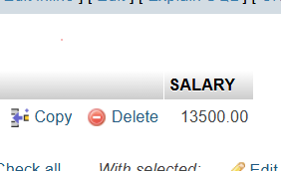

MySQL JOINS [13 Exercises]

**1.** Write a [MySQL](https://www.w3resource.com/mysql-exercises/join-exercises/) query to find the addresses (location_id, street_address, city, state_province, country_name) of all the departments.  
Hint : Use NATURAL JOIN.

[SELECT](http://localhost/phpmyadmin/url.php?url=https://dev.mysql.com/doc/refman/8.0/en/select.html) location_id, street_address, city, state_province, country_name FROM locations NATURAL JOIN countries;

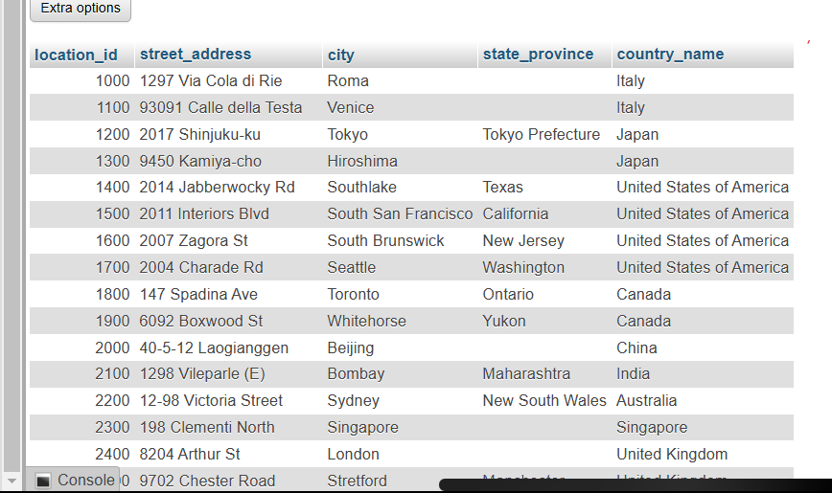

**2.** Write a MySQL query to find the name (first_name, last name), department ID and name of all the employees

[SELECT](http://localhost/phpmyadmin/url.php?url=https://dev.mysql.com/doc/refman/8.0/en/select.html) first_name, last_name, e.department_id, d.department_name FROM employees AS e JOIN departments AS d ON e.department_id = d.department_id;

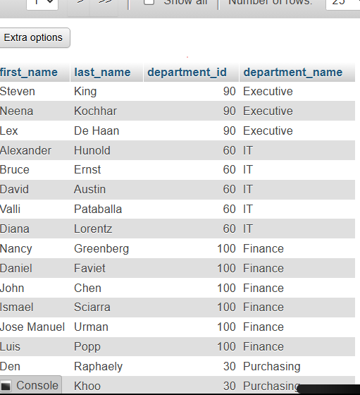

**3.** Write a [MySQL](https://www.w3resource.com/mysql-exercises/join-exercises/) query to find the name (first_name, last_name), job, department ID and name of the employees who works in London.

[SELECT](http://localhost/phpmyadmin/url.php?url=https://dev.mysql.com/doc/refman/8.0/en/select.html) e.FIRST_NAME, e.LAST_NAME, e.JOB_ID AS JOB, e.DEPARTMENT_ID, d.DEPARTMENT_NAME FROM employees e JOIN departments d ON e.DEPARTMENT_ID = d.DEPARTMENT_ID JOIN locations l ON d.LOCATION_ID = l.LOCATION_ID WHERE l.CITY = 'London';

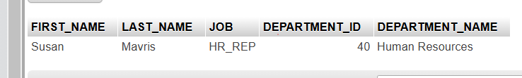

4 . Write a MySQL query to find the employee id, name (last_name) along with their manager_id and name (last_name).

[SELECT](http://localhost/phpmyadmin/url.php?url=https://dev.mysql.com/doc/refman/8.0/en/select.html) e.EMPLOYEE_ID AS Employee_ID, e.LAST_NAME AS Employee_Name, e.MANAGER_ID AS Manager_ID, m.LAST_NAME AS Manager_Name FROM employees e [LEFT](http://localhost/phpmyadmin/url.php?url=https://dev.mysql.com/doc/refman/8.0/en/string-functions.html%23function_left) JOIN employees m ON e.MANAGER_ID = m.EMPLOYEE_ID;

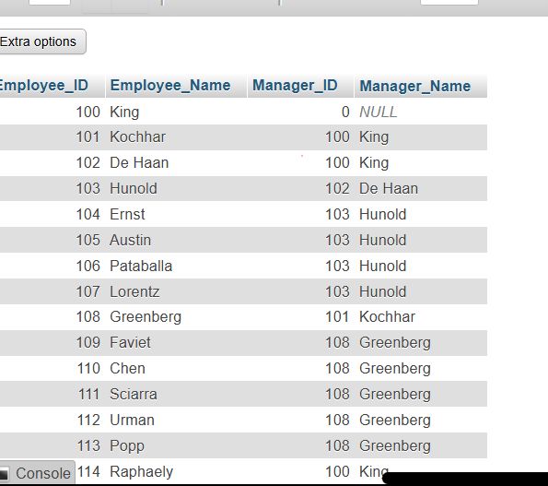

5. Write a [MySQL](https://www.w3resource.com/mysql-exercises/join-exercises/) query to find the name (first_name, last_name) and hire date of the employees who was hired after 'Jones'.

[SELECT](http://localhost/phpmyadmin/url.php?url=https://dev.mysql.com/doc/refman/8.0/en/select.html) FIRST_NAME, LAST_NAME, HIRE_DATE FROM employees WHERE HIRE_DATE > ( [SELECT](http://localhost/phpmyadmin/url.php?url=https://dev.mysql.com/doc/refman/8.0/en/select.html) HIRE_DATE FROM employees WHERE LAST_NAME = 'Jones' );

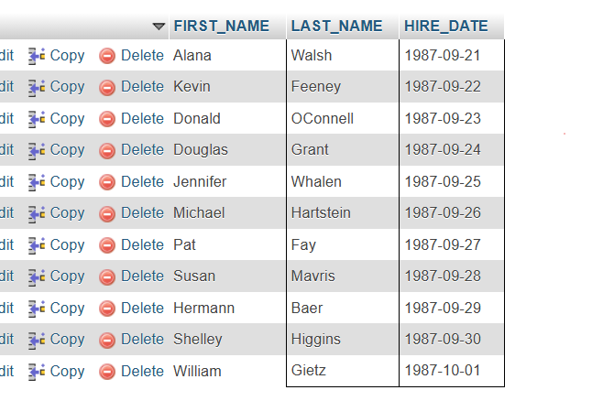

**6.** Write a [MySQL](https://www.w3resource.com/mysql-exercises/join-exercises/) query to get the department name and number of employees in the department.

[SELECT](http://localhost/phpmyadmin/url.php?url=https://dev.mysql.com/doc/refman/8.0/en/select.html) d.DEPARTMENT_NAME, [COUNT](http://localhost/phpmyadmin/url.php?url=https://dev.mysql.com/doc/refman/8.0/en/aggregate-functions.html%23function_count)(e.EMPLOYEE_ID) AS NUMBER_OF_EMPLOYEES FROM departments d [LEFT](http://localhost/phpmyadmin/url.php?url=https://dev.mysql.com/doc/refman/8.0/en/string-functions.html%23function_left) JOIN employees e ON d.DEPARTMENT_ID = e.DEPARTMENT_ID GROUP BY d.DEPARTMENT_NAME;

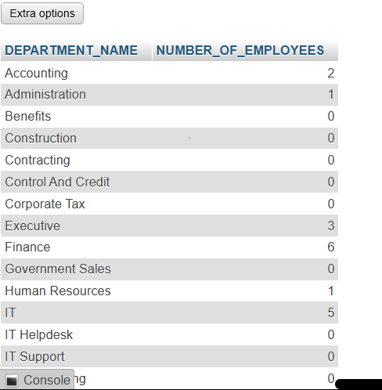

**7.** Write a [MySQL](https://www.w3resource.com/mysql-exercises/join-exercises/) query to find the employee ID, job title, number of days between ending date and starting date for all jobs in department 90.

[SELECT](http://localhost/phpmyadmin/url.php?url=https://dev.mysql.com/doc/refman/8.0/en/select.html) EMPLOYEE_ID, JOB_ID AS JOB_TITLE, DATEDIFF(END_DATE, START_DATE) AS DAYS_WORKED FROM job_history WHERE DEPARTMENT_ID = 90;

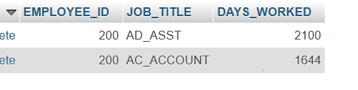

1. . Write a [MySQL](https://www.w3resource.com/mysql-exercises/join-exercises/) query to display the department ID and name and first name of manager.

[SELECT](http://localhost/phpmyadmin/url.php?url=https://dev.mysql.com/doc/refman/8.0/en/select.html) d.DEPARTMENT_ID, d.DEPARTMENT_NAME, e.FIRST_NAME AS MANAGER_FIRST_NAME FROM departments d JOIN employees e ON d.MANAGER_ID = e.EMPLOYEE_ID;

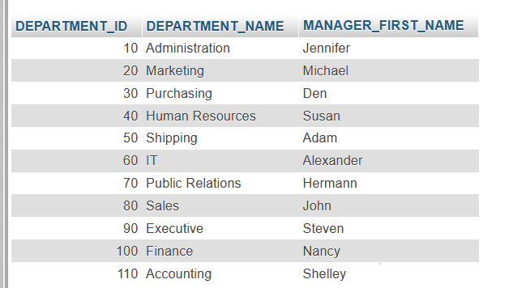

1. Write a [MySQL](https://www.w3resource.com/mysql-exercises/join-exercises/) query to display the department name, manager name, and city.

[SELECT](http://localhost/phpmyadmin/url.php?url=https://dev.mysql.com/doc/refman/8.0/en/select.html) d.DEPARTMENT_NAME, CONCAT(e.FIRST_NAME, ' ', e.LAST_NAME) AS MANAGER_NAME, l.CITY FROM departments d JOIN employees e ON d.MANAGER_ID = e.EMPLOYEE_ID JOIN locations l ON d.LOCATION_ID = l.LOCATION_ID;

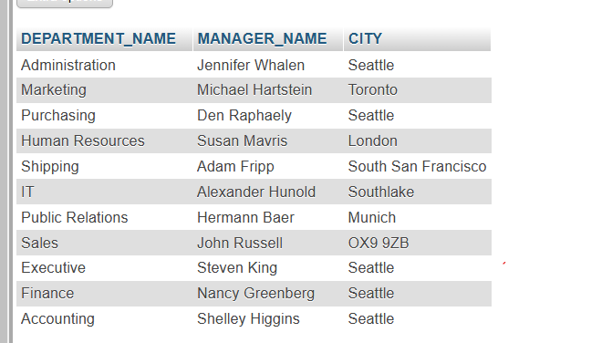

1. Write a [MySQL](https://www.w3resource.com/mysql-exercises/join-exercises/) query to display the job title and average salary of employees.

[SELECT](http://localhost/phpmyadmin/url.php?url=https://dev.mysql.com/doc/refman/8.0/en/select.html) j.JOB_TITLE, [AVG](http://localhost/phpmyadmin/url.php?url=https://dev.mysql.com/doc/refman/8.0/en/aggregate-functions.html%23function_avg)(e.SALARY) AS Average_Salary FROM employees e JOIN jobs j ON e.JOB_ID = j.JOB_ID GROUP BY j.JOB_TITLE;

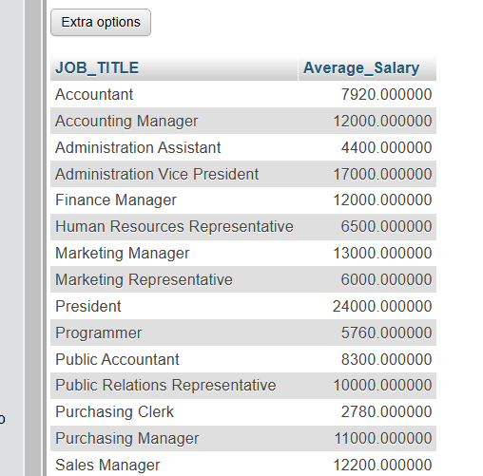

1. Write a MySQL query to display job title, employee name, and the difference between salary of the employee and minimum salary for the job.

[SELECT](http://localhost/phpmyadmin/url.php?url=https://dev.mysql.com/doc/refman/8.0/en/select.html) e.JOB_ID, CONCAT(e.FIRST_NAME, ' ', e.LAST_NAME) AS EMPLOYEE_NAME, e.SALARY - ([SELECT](http://localhost/phpmyadmin/url.php?url=https://dev.mysql.com/doc/refman/8.0/en/select.html) [MIN](http://localhost/phpmyadmin/url.php?url=https://dev.mysql.com/doc/refman/8.0/en/aggregate-functions.html%23function_min)(SALARY) FROM employees WHERE JOB_ID = e.JOB_ID) AS SALARY_DIFF FROM employees e;

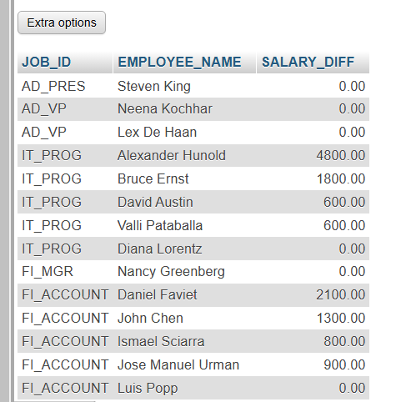

1. Write a [MySQL](https://www.w3resource.com/mysql-exercises/join-exercises/) query to display the job history that were done by any employee who is currently drawing more than 10000 of salary.

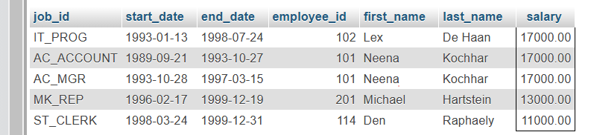

1. Write a [MySQL](https://www.w3resource.com/mysql-exercises/join-exercises/) query to display department name, name (first_name, last_name), hire date, salary of the manager for all managers whose experience is more than 15 years.

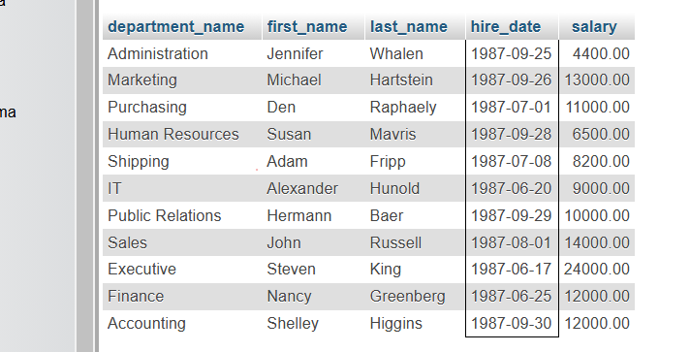

MySQL Date Time [21 Exercises]

1. Write a query to display the first day of the month (in datetime format) three months before the current month.  
   Sample current date : 2014-09-03  
   Expected result : 2014-06-01

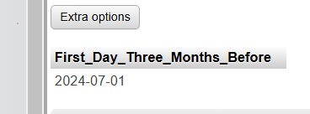

2. Write a query to display the last day of the month (in datetime format) three months before the current month.

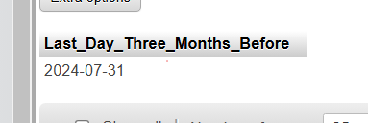

3. Write a query to get the distinct Mondays from hire_date in employees tables.

[SELECT](http://localhost/phpmyadmin/url.php?url=https://dev.mysql.com/doc/refman/8.0/en/select.html) DISTINCT hire_date FROM employees WHERE DAYOFWEEK(hire_date) = 2;

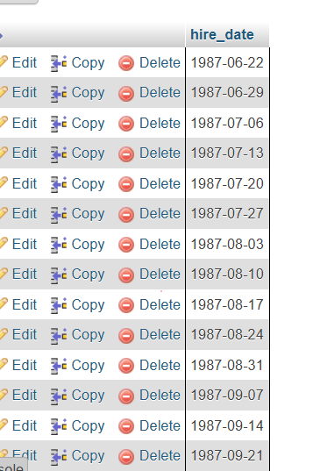

1. Write a query to get the first day of the current year.

SELECT DATE(CONCAT(YEAR(CURDATE()), '-01-01')) AS First_Day_Current_Year;

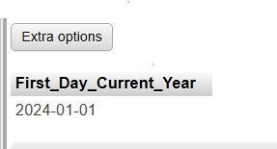

1. Write a query to get the last day of the current year.

SELECT LAST_DAY(CONCAT(YEAR(CURDATE()), '-12-01')) AS Last_Day_Current_Year;



1. Write a query to calculate the age in year

[SELECT](http://localhost/phpmyadmin/url.php?url=https://dev.mysql.com/doc/refman/8.0/en/select.html) TIMESTAMPDIFF(YEAR, "1967-06-08", CURDATE()) AS age;



1. Write a query to get the current date in the following format.  
   Sample date : 2014-09-04  
   Output : September 4, 2014

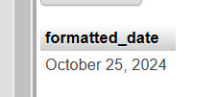

1. Write a query to get the current date in Thursday September 2014 format.  
   Thursday September 2014

[SELECT](http://localhost/phpmyadmin/url.php?url=https://dev.mysql.com/doc/refman/8.0/en/select.html) CONCAT(DAYNAME(CURDATE()), ' ', DATE_FORMAT(CURDATE(), '%M %Y')) AS formatted_date;

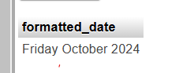

1. Write a query to extract the year from the current date.

[SELECT](http://localhost/phpmyadmin/url.php?url=https://dev.mysql.com/doc/refman/8.0/en/select.html) YEAR(CURDATE()) AS current_year;

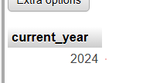

1. Write a query to get the DATE value from a given day (number in N).  
   Sample days: 730677

[SELECT](http://localhost/phpmyadmin/url.php?url=https://dev.mysql.com/doc/refman/8.0/en/select.html) DATE_ADD('0000-01-01', [INTERVAL](http://localhost/phpmyadmin/url.php?url=https://dev.mysql.com/doc/refman/8.0/en/comparison-operators.html%23function_interval) 730677 DAY) AS output_date;



1. Write a query to get the first name and hire date from employees table where hire date between '1987-06-01' and '1987-07-30'

[SELECT](http://localhost/phpmyadmin/url.php?url=https://dev.mysql.com/doc/refman/8.0/en/select.html) first_name, hire_date FROM employees WHERE hire_date BETWEEN '1987-06-01' [AND](http://localhost/phpmyadmin/url.php?url=https://dev.mysql.com/doc/refman/8.0/en/logical-operators.html%23operator_and) '1987-07-30';  
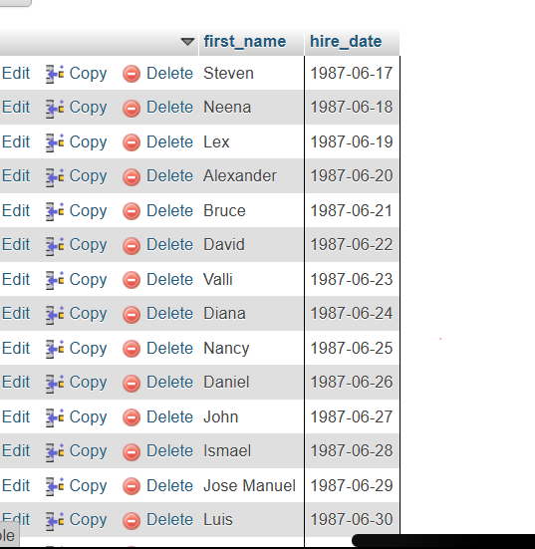

**12.** Write a query to display the current date in the following format.  
Sample output: Thursday 4th September 2014 00:00:00

[SELECT](http://localhost/phpmyadmin/url.php?url=https://dev.mysql.com/doc/refman/8.0/en/select.html) DATE_FORMAT(CURDATE(), CONCAT('%W %e', [IF](http://localhost/phpmyadmin/url.php?url=https://dev.mysql.com/doc/refman/8.0/en/control-flow-functions.html%23function_if)(DAY(CURDATE()) [IN](http://localhost/phpmyadmin/url.php?url=https://dev.mysql.com/doc/refman/8.0/en/comparison-operators.html%23function_in) (1,21,31), 'st', [IF](http://localhost/phpmyadmin/url.php?url=https://dev.mysql.com/doc/refman/8.0/en/control-flow-functions.html%23function_if)(DAY(CURDATE()) [IN](http://localhost/phpmyadmin/url.php?url=https://dev.mysql.com/doc/refman/8.0/en/comparison-operators.html%23function_in) (2,22), 'nd', [IF](http://localhost/phpmyadmin/url.php?url=https://dev.mysql.com/doc/refman/8.0/en/control-flow-functions.html%23function_if)(DAY(CURDATE()) [IN](http://localhost/phpmyadmin/url.php?url=https://dev.mysql.com/doc/refman/8.0/en/comparison-operators.html%23function_in) (3,23), 'rd', 'th')))), ' %M %Y 00:00:00') AS formatted_date;



1. Write a query to display the current date in the following format.  
   Sample output: 05/09/2014

[SELECT](http://localhost/phpmyadmin/url.php?url=https://dev.mysql.com/doc/refman/8.0/en/select.html) DATE_FORMAT(CURDATE(), '%d/%m/%Y') AS formatted_date;  


**14.** Write a query to display the current date in the following format.  
Sample output: 12:00 AM Sep 5, 2014

[SELECT](http://localhost/phpmyadmin/url.php?url=https://dev.mysql.com/doc/refman/8.0/en/select.html) DATE_FORMAT(CURDATE(), '%d/%m/%Y') AS formatted_date;



1. Write a query to get the firstname, lastname who joined in the month of June.

[SELECT](http://localhost/phpmyadmin/url.php?url=https://dev.mysql.com/doc/refman/8.0/en/select.html) FIRST_NAME, LAST_NAME FROM employees WHERE MONTH(HIRE_DATE) = 6;

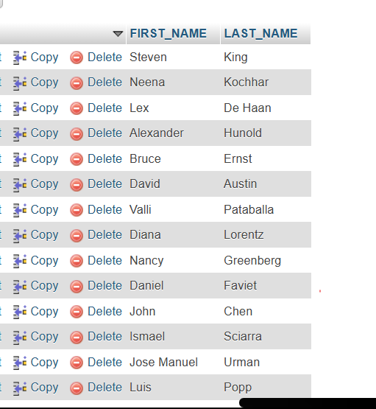

**16.** Write a query to get the years in which more than 10 employees joined.

[SELECT](http://localhost/phpmyadmin/url.php?url=https://dev.mysql.com/doc/refman/8.0/en/select.html) YEAR(HIRE_DATE) AS join_year, [COUNT](http://localhost/phpmyadmin/url.php?url=https://dev.mysql.com/doc/refman/8.0/en/aggregate-functions.html%23function_count)(*) AS employee_count FROM employees GROUP BY YEAR(HIRE_DATE) HAVING [COUNT](http://localhost/phpmyadmin/url.php?url=https://dev.mysql.com/doc/refman/8.0/en/aggregate-functions.html%23function_count)(*) > 10;  


**17.** Write a query to get first name of employees who joined in 1987.

[SELECT](http://localhost/phpmyadmin/url.php?url=https://dev.mysql.com/doc/refman/8.0/en/select.html) FIRST_NAME FROM employees WHERE YEAR(HIRE_DATE) = 1987;

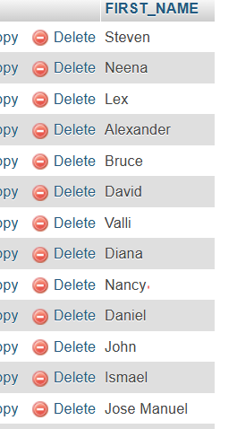

**18.** Write a query to get department name, manager name, and salary of the manager for all managers whose experience is more than 5 years.

[SELECT](http://localhost/phpmyadmin/url.php?url=https://dev.mysql.com/doc/refman/8.0/en/select.html) d.DEPARTMENT_NAME, CONCAT(m.FIRST_NAME, ' ', m.LAST_NAME) AS manager_name, m.SALARY AS manager_salary FROM employees m JOIN departments d ON m.DEPARTMENT_ID = d.DEPARTMENT_ID WHERE m.HIRE_DATE <= DATE_SUB(CURDATE(), [INTERVAL](http://localhost/phpmyadmin/url.php?url=https://dev.mysql.com/doc/refman/8.0/en/comparison-operators.html%23function_interval) 5 YEAR);

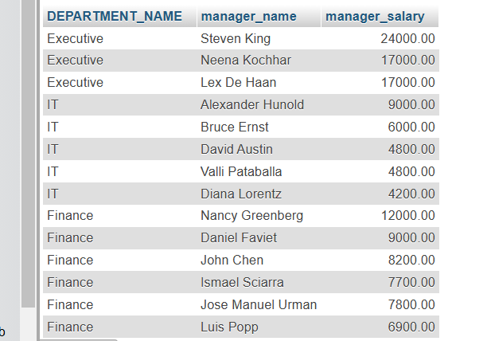

**19.** Write a query to get employee ID, last name, and date of first salary of the employees.

[SELECT](http://localhost/phpmyadmin/url.php?url=https://dev.mysql.com/doc/refman/8.0/en/select.html) EMPLOYEE_ID, LAST_NAME, HIRE_DATE AS first_salary_date FROM employees;

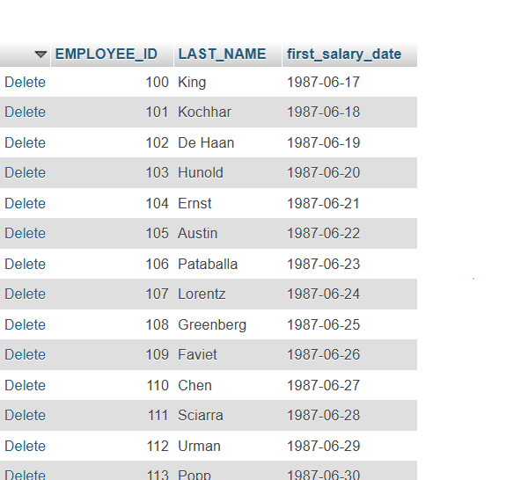

**20.** Write a query to get first name, hire date and experience of the employees.

[SELECT](http://localhost/phpmyadmin/url.php?url=https://dev.mysql.com/doc/refman/8.0/en/select.html) FIRST_NAME, HIRE_DATE, YEAR(CURDATE()) - YEAR(HIRE_DATE) - (DATE_FORMAT(CURDATE(), '%m%d') < DATE_FORMAT(HIRE_DATE, '%m%d')) AS experience FROM employees;

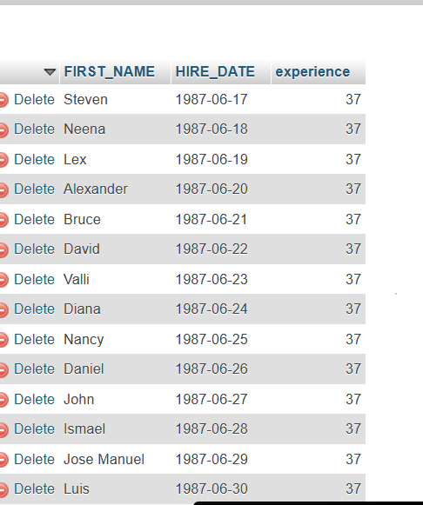

**21.** Write a query to get the department ID, year, and number of employees joined.

[SELECT](http://localhost/phpmyadmin/url.php?url=https://dev.mysql.com/doc/refman/8.0/en/select.html) DEPARTMENT_ID, YEAR(HIRE_DATE) AS year, [COUNT](http://localhost/phpmyadmin/url.php?url=https://dev.mysql.com/doc/refman/8.0/en/aggregate-functions.html%23function_count)(*) AS number_of_employees_joined FROM employees GROUP BY DEPARTMENT_ID, YEAR(HIRE_DATE) ORDER BY DEPARTMENT_ID, year;

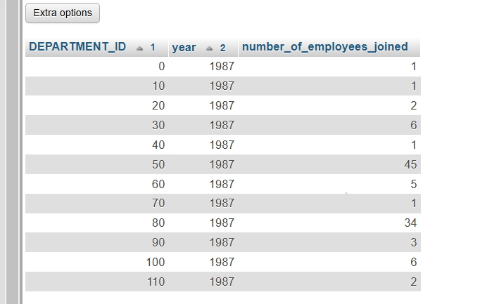

MySQL String Functions [17 Exercises]

1. Write a [MySQL](https://www.w3resource.com/mysql-exercises/string-exercises/) query to get the job_id and related employee's id.

[SELECT](http://localhost:8080/phpmyadmin/url.php?url=https://dev.mysql.com/doc/refman/8.0/en/select.html) JOB_ID, [GROUP_CONCAT](http://localhost:8080/phpmyadmin/url.php?url=https://dev.mysql.com/doc/refman/8.0/en/aggregate-functions.html%23function_group_concat)(EMPLOYEE_ID, '') AS EMPLOYEE_ID FROM employees GROUP BY JOB_ID;



**2.** Write a MySQL query to update the portion of the phone_number in the employees table, within the phone number the substring '124' will be replaced by '999'.

[SELECT](http://localhost:8080/phpmyadmin/url.php?url=https://dev.mysql.com/doc/refman/8.0/en/select.html) [REPLACE](http://localhost:8080/phpmyadmin/url.php?url=https://dev.mysql.com/doc/refman/8.0/en/replace.html)(PHONE_NUMBER, 124, 999) AS PHONE_NUMBER FROM employees;

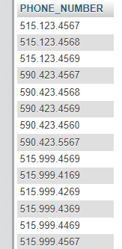

**3.** Write a MySQL query to get the details of the employees where the length of the first name greater than or equal to 8.

[SELECT](http://localhost:8080/phpmyadmin/url.php?url=https://dev.mysql.com/doc/refman/8.0/en/select.html) FIRST_NAME FROM employees WHERE LENGTH(FIRST_NAME) >= 8;

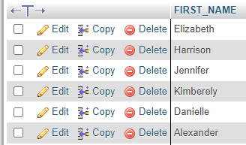

**4.** Write a [MySQL](https://www.w3resource.com/mysql-exercises/string-exercises/) query to display leading zeros before maximum and minimum salary.

[SELECT](http://localhost:8080/phpmyadmin/url.php?url=https://dev.mysql.com/doc/refman/8.0/en/select.html) LPAD(MIN_SALARY,6,0) MIN_SALARY,LPAD(MAX_SALARY,6,0) MAX_SALARY FROM jobs;

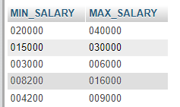

**5.** Write a MySQL query to append '@example.com' to email field.

[SELECT](http://localhost:8080/phpmyadmin/url.php?url=https://dev.mysql.com/doc/refman/8.0/en/select.html) CONCAT(EMAIL, '@example.com') FROM employees;

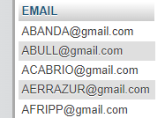

**6.** Write a [MySQL](https://www.w3resource.com/mysql-exercises/string-exercises/) query to get the employee id, first name and hire month.

[SELECT](http://localhost:8080/phpmyadmin/url.php?url=https://dev.mysql.com/doc/refman/8.0/en/select.html) EMPLOYEE_ID, FIRST_NAME, LPAD(MONTH(HIRE_DATE),2,0) HIRE_MONTH FROM employees;

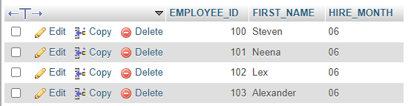

**7.** Write a [MySQL](https://www.w3resource.com/mysql-exercises/string-exercises/) query to get the employee id, email id (discard the last three characters).

[SELECT](http://localhost:8080/phpmyadmin/url.php?url=https://dev.mysql.com/doc/refman/8.0/en/select.html) EMPLOYEE_ID, REVERSE(SUBSTR(REVERSE(EMAIL),4)) FROM employees;

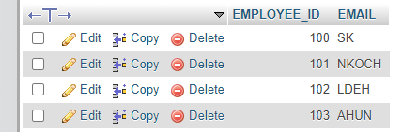

**8.** Write a [MySQL](https://www.w3resource.com/mysql-exercises/string-exercises/) query to find all employees where first names are in upper case.

[SELECT](http://localhost:8080/phpmyadmin/url.php?url=https://dev.mysql.com/doc/refman/8.0/en/select.html) * FROM employees WHERE [BINARY](http://localhost:8080/phpmyadmin/url.php?url=https://dev.mysql.com/doc/refman/8.0/en/cast-functions.html%23operator_binary) FIRST_NAME = UPPER(FIRST_NAME);



**9.**Write a [MySQL](https://www.w3resource.com/mysql-exercises/string-exercises/) query to extract the last 4 character of phone numbers.

[SELECT](http://localhost:8080/phpmyadmin/url.php?url=https://dev.mysql.com/doc/refman/8.0/en/select.html) REVERSE(SUBSTR(REVERSE(PHONE_NUMBER),1,4)) AS PHONE_NUMBER FROM employees;

OR

[SELECT](http://localhost:8080/phpmyadmin/url.php?url=https://dev.mysql.com/doc/refman/8.0/en/select.html) [RIGHT](http://localhost:8080/phpmyadmin/url.php?url=https://dev.mysql.com/doc/refman/8.0/en/string-functions.html%23function_right)(PHONE_NUMBER,4) AS PHONE_NUMBER FROM employees;

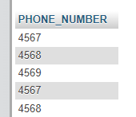

**10.** Write a [MySQL](https://www.w3resource.com/mysql-exercises/string-exercises/) query to get the last word of the street address.

[SELECT](http://localhost:8080/phpmyadmin/url.php?url=https://dev.mysql.com/doc/refman/8.0/en/select.html) SUBSTRING_INDEX(TRIM(STREET_ADDRESS), ' ', -1) AS last_word FROM locations;

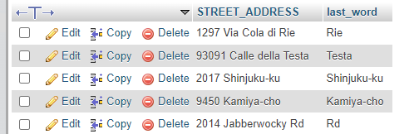

**11.** Write a MySQL query to get the locations that have minimum street length.

[SELECT](http://localhost:8080/phpmyadmin/url.php?url=https://dev.mysql.com/doc/refman/8.0/en/select.html) STREET_ADDRESS FROM locations WHERE LENGTH(TRIM(STREET_ADDRESS)) = ( [SELECT](http://localhost:8080/phpmyadmin/url.php?url=https://dev.mysql.com/doc/refman/8.0/en/select.html) [MIN](http://localhost:8080/phpmyadmin/url.php?url=https://dev.mysql.com/doc/refman/8.0/en/aggregate-functions.html%23function_min)(LENGTH(TRIM(STREET_ADDRESS))) FROM locations );

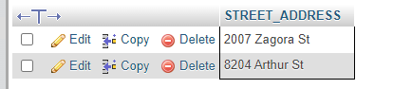

**12.** Write a MySQL query to display the first word from those job titles which contains more than one words.

[SELECT](http://localhost:8080/phpmyadmin/url.php?url=https://dev.mysql.com/doc/refman/8.0/en/select.html) JOB_TITLE, SUBSTRING_INDEX(JOB_TITLE, ' ', 1) AS FIRST_WORD FROM jobs WHERE JOB_TITLE [LIKE](http://localhost:8080/phpmyadmin/url.php?url=https://dev.mysql.com/doc/refman/8.0/en/string-comparison-functions.html%23operator_like) '% %';

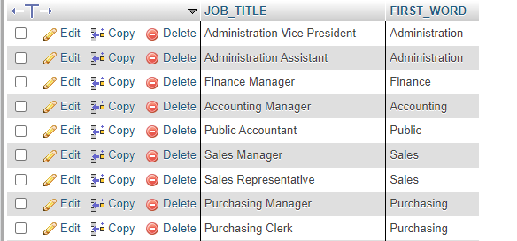

**13.** Write a MySQL query to display the first name and last name for employees where first occurrence of last name contain character 'c' after 2nd position.

[SELECT](http://localhost:8080/phpmyadmin/url.php?url=https://dev.mysql.com/doc/refman/8.0/en/select.html) FIRST_NAME, LAST_NAME FROM employees WHERE LOCATE('c', LAST_NAME) > 2;

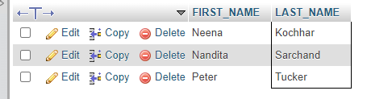

**14.** Write a [MySQL](https://www.w3resource.com/mysql-exercises/string-exercises/) query that displays the first name and the length of the first name for all employees whose name starts with the letters 'A', 'J' or 'M'. Give each column an appropriate label. Sort the results by the employees' first names.

[SELECT](http://localhost:8080/phpmyadmin/url.php?url=https://dev.mysql.com/doc/refman/8.0/en/select.html) FIRST_NAME, LENGTH(FIRST_NAME) LENGTH FROM employees WHERE FIRST_NAME [LIKE](http://localhost:8080/phpmyadmin/url.php?url=https://dev.mysql.com/doc/refman/8.0/en/string-comparison-functions.html%23operator_like) 'A%' [OR](http://localhost:8080/phpmyadmin/url.php?url=https://dev.mysql.com/doc/refman/8.0/en/logical-operators.html%23operator_or) FIRST_NAME [LIKE](http://localhost:8080/phpmyadmin/url.php?url=https://dev.mysql.com/doc/refman/8.0/en/string-comparison-functions.html%23operator_like) 'J%' [OR](http://localhost:8080/phpmyadmin/url.php?url=https://dev.mysql.com/doc/refman/8.0/en/logical-operators.html%23operator_or) FIRST_NAME [LIKE](http://localhost:8080/phpmyadmin/url.php?url=https://dev.mysql.com/doc/refman/8.0/en/string-comparison-functions.html%23operator_like) 'M%' ORDER BY FIRST_NAME;

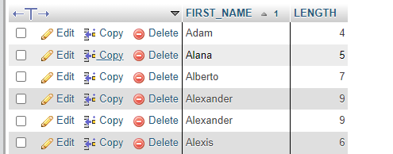

**15.** Write a [MySQL](https://www.w3resource.com/mysql-exercises/string-exercises/) query to display the first name and salary for all employees. Format the salary to be 10 characters long, left-padded with the $ symbol. Label the column SALARY.

[SELECT](http://localhost:8080/phpmyadmin/url.php?url=https://dev.mysql.com/doc/refman/8.0/en/select.html) FIRST_NAME, LPAD(SALARY,10,'$') SALARY FROM employees;

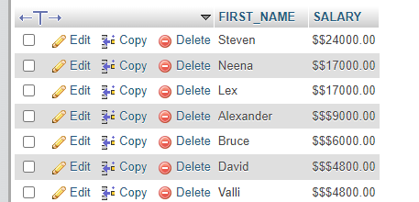

**16.** Write a [MySQL](https://www.w3resource.com/mysql-exercises/string-exercises/) query to display the first eight characters of the employees' first names and indicates the amounts of their salaries with '$' sign. Each '$' sign signifies a thousand dollars. Sort the data in descending order of salary.

SELECT LPAD(“”, FLOOR(SALARY / 1000), '$') AS SALARY FROM employees;

OR

[SELECT](http://localhost:8080/phpmyadmin/url.php?url=https://dev.mysql.com/doc/refman/8.0/en/select.html) [LEFT](http://localhost:8080/phpmyadmin/url.php?url=https://dev.mysql.com/doc/refman/8.0/en/string-functions.html%23function_left)(FIRST_NAME, 8) FIRST_NAME, [REPEAT](http://localhost:8080/phpmyadmin/url.php?url=https://dev.mysql.com/doc/refman/8.0/en/string-functions.html%23function_repeat)('$', FLOOR(SALARY/1000)) 'SALARY($)', SALARY FROM employees;

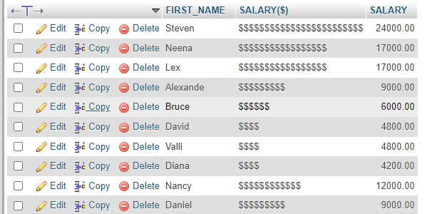

**17.** Write a [MySQL](https://www.w3resource.com/mysql-exercises/string-exercises/) query to display the employees with their code, first name, last name and hire date who hired either on seventh day of any month or seventh month in any year.

[SELECT](http://localhost:8080/phpmyadmin/url.php?url=https://dev.mysql.com/doc/refman/8.0/en/select.html) EMPLOYEE_ID, FIRST_NAME, LAST_NAME,HIRE_DATE FROM employees WHERE DAY(hire_date) = 7 [OR](http://localhost:8080/phpmyadmin/url.php?url=https://dev.mysql.com/doc/refman/8.0/en/logical-operators.html%23operator_or) MONTH(hire_date) = 7;

